LAB (4)

ID : 2240005893

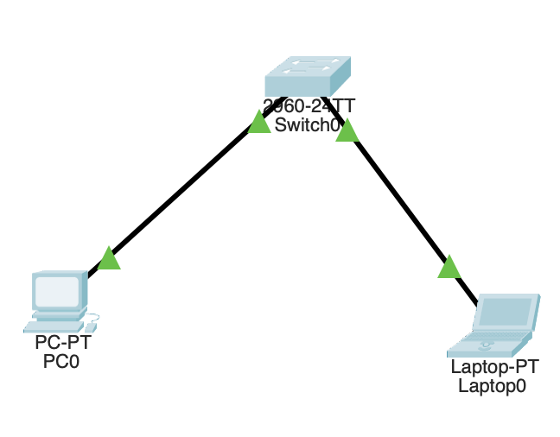
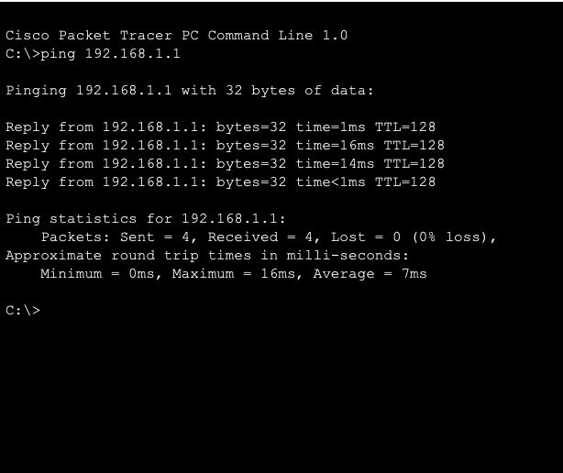
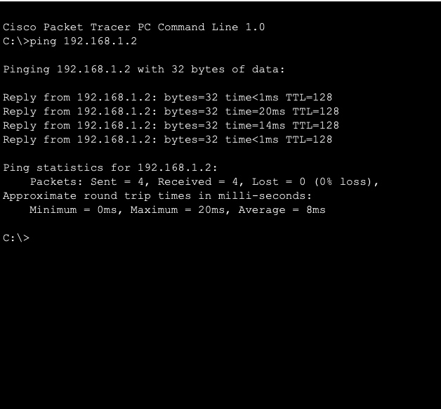

1. How you can change a computer name?
[ start – settings – system – about – rename ]
2. Open Command Prompt. How?
[ start – search – command prompt ]

